**Model Performance Metrics**

1. Confusion Matrix

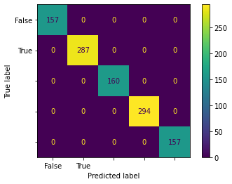

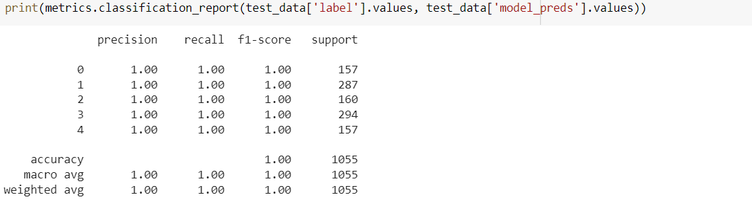

1. Accuracy – 100 %



1. Precision – 100 %



1. Recall – 100 %



1. Specificity – 100 %



1. F1-Score – 100 %

